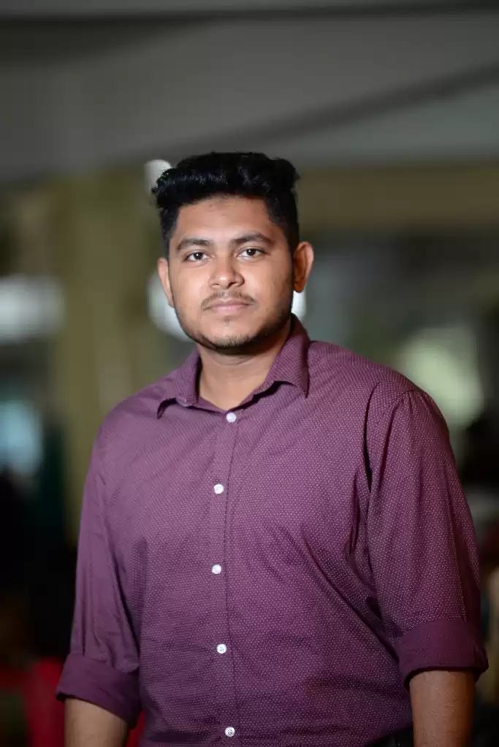
SAYED ISLAM SAFIN

Bashundhara R/A, Dhaka
Phone: +8801856777055
Email: safinweb777@gmail.com

LinkedIn: https://www.linkedin.com/in/sayed-islam-safin-902a16172
GitHub: https://github.com/safin777.
HackerRank: https://www.hackerrank.com/sayedislamsafin1

Career Objective

Seeking to advance a growing tech career as a Software Developer. Offering skills in application development and object-oriented languages to develop superior software applications and other core systems.

Professional Summary

- Teaching Assistant, American International University-Bangladesh (January,2021-April,2021)
- Have been expertized in online based class maintaining system and covering all facts.
- Tutored struggling students individually and in small groups to reinforce learning concepts.
- Participated in professional development opportunities and attended in-services and seminars.
- Assisted teachers with classroom management and document coordination to maintain positive learning environment.

- Full Stack Web Developer(Intern), Infolink Limited.(March,2021-June,2021)

- Managed to publish the website with team.
- Laravel Framework with PHP, Javascript,AJAX, MySql Database and Bootstrap have been used to cover up front and back-end.
- It is a large ERP Management System with a Blog Website and Ecommerce. For review here is the link of the website.
- I had designed few portion of Admin Panel and few portion of backend of the Admin panel.
- Worked on live project in Cpanel in according to software development method.
- Also made API for mobile application to fetch live data.

Educational Profile

- B.Sc. in Software Engineering (2017-2021), American International University-Bangladesh (AIUB)
- CGPA-3.72.
- Obtain Academic Scholarship(With financial Aid based on result)
- Member of AIUB Computer Club.
- Participated on AIUB CS FEST Programming Contest(2018).
- Participated on ACM-ICPC 2018 AIUB Team Selection Contest (Team-AIUB CODE HUNTER).

- Higher Secondary Certificate (2016), Rangunia Govt. College,Chittagong.
- ^{Obtain GPA-4.33}

- Secondary School Certificate (2014), Rangunia Public School & College,Chittagong
- Obtain GPA 5.00
- Obtained Government Scholarship in General quota.

Highlights of Qualifications

- Experience in developing materials for computer science courses specially for C#, PHP, Java and other programming languages.

- Good knowledge in entity framework in Laravel, RESTful API,Express Js,Node Js.

- Good knowledge of Dynamic Programming and Relational Database.

- Proficient knowledge in Software designing model, Requirement Engineering, UML and Development and Project Management.

Software Proficiency

• | Operating System | : | Windows 7/8/10, Linux(Ubunto).
• | Languages | : | C#, Core Java, C, C++ , PHP, JavaScript, HTML,CSS,Python.
• | RDBMS | : | Oracle, Microsoft SQL Server, MySQL, phpMyAdmin
• | Web Frameworks | : | Laravel, Express Js , React.
• | Simulation Tool | : | Cisco Packet Tracer (Networking)
• | IDE | : | Microsoft Visual Studio, Sublime Text, Code Blocks,Atom.
• | API | : | RESTful API (PostMan and VS code extension)
• | Other | : | Assembly Language using emu 8086
Academic Research

- A research paper titled “Crops Disease Detection Using Improved Convolutional Neural Network” have been done in Artificial Intelligence Domain.

Academic Projects
- Online School Management.
- Frontend:HTML,CSS,JS,Bootstrap,Javascript.
- Backend:PHP,MySql.
- Framework:Laravel.
https://github.com/safin777/School-CRM

- Agriculture farm Management.
- Back-end: C#
- https://github.com/safin777/Agriculture-Farm-Management-System-.Net-Project-.git.

- AIUB BLOG(Blog Website)
- Frontend:HTML,CSS,JS,Bootstrap.
- Backend:PHP,MySql.
- Framework:Laravel.
- https://github.com/safin777/Individual-assignment.git

- Bank Management system.
- Backend: Java, Java Swing.
- https://github.com/safin777/Bank-management-java-.git.

- Agro Farm Management and Ecommerce.
- Frontend:HTML,CSS,JS,Bootstrap.
- Backend:PHP,MySql.
- Framework:Laravel.
- https://github.com/safin777/Agro-farm-laravel
Personal Details

Name: Sayed Islam Safin.

Father: Late MD.Sirazul Islam.

Mother: Rehana Begum.

Religion: Islam.

Sex: Male.

Blood Gropu: B (+ ve).

